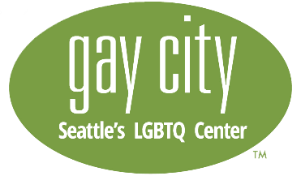

Youth Advocacy Media group plan and group description
Gay City: Seattle’s LGBTQ Center

Our Youth Advocacy Media program is an eight month program where youth will learn about advocating for LGBTQ+ health issues, utilizing various forms of media. LGBTQ+ Youth ages 12-20 are welcome to join starting October 2019, with the program ending in June of 2020.
The main goal of this program is to produce marijuana prevention media (videos, images, blog posts, etc). Gay City: Seattle’s LGBTQ Center is working on a project for the Department of Health to reduce marijuana use among LGBTQ+ youth in Washington State. This is an opportunity to ensure that our marijuana prevention efforts actually benefit LGBTQ+ youth. At Gay City, we believe in bolstering protective factors that help prevent substance abuse, such as promoting mental health, instead of relying on scare tactics or "just say no" campaigns.

That's where you come in; we need your help developing marijuana prevention and health messaging and sharing it through media channels. You will gain valuable knowledge of video, photography, blogging, and other forms of media, while assisting Gay City’s marketing team in finding and sharing content for our youth health focused social media brand, Queercore. The goal in building this online, youth-focused brand is to increase the reach and engagement of the health messaging.

Youth will gain:
- Understanding of health and social justice issues facing members of LGBTQ+ communities
- Knowledge of how to build a brand online to strengthen your voice and advocate for your peers
- Effective social media management for health promotion and marketing
- Media skills in video, photography, blogging, or another chosen media form
- Connections with other LGBTQ teens, and experience working in groups
- $20 per hour for monthly meetings (2 hours), with additional paid opportunities available later on
- Guidance towards actualizing personal goals as they relate to the project, or to fulfill school/practicum project, internship, or volunteer requirements.

Group sessions will explore:
- Gay City’s findings from marijuana prevention focus groups with queer youth, and health disparities
- Content marketing, social media, vlogging
- Podcasts/Radio
- Public Speaking
- Film/TV/Photography
- Branding
- Blogging, content-writing
- Advocacy
- Review, Awards

Requirements & Expectations:
- Ability to attend meetings at least once per month from October 2019 through June 2020, either in person (Greater Seattle area) or online/by phone
- Eagerness to participate in creation of one group media project per month
- Open to all LGBTQ+ (Lesbian, Gay, Bisexual, Transgender, Queer, Gender nonconforming, or otherwise queer) identifying youth
- Be between 12 and 20 years old

To apply, please visit gaycity.org/YouthMediaGroup or email Andrew@gaycity.org

